Exclusive: The Walking Dead Star IronE Singleton Talks More T-Dog, Return of Merle, and the Rest of Season 2
By
Adam Wright
– November 20, 2011Posted in: News, Preview, TVDoneWright.com Features
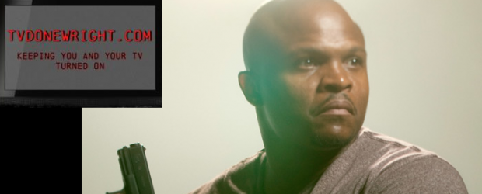
By: Adam Wright
When The Walking Dead returned for a 2nd season on AMC, it broke cable ratings records. The zombie-apocalypse drama was bigger than ever.
Now we are approaching the midway point of Season 2. The survivors are at Herschel’s farm, but secrets are brewing within the camp.
The Walking Dead star IronE Singleton has taken time to have a chat with us once again. I first talked to “T-Dog” himself last December at the end of the 1st season. This time around, he talks about the rising success of The Walking Dead, what’s next for T-Dog, and of course he talks about that “Walker in the Well”.
Here’s what IronE had to say:
***
Adam: The Walking Dead premiered its 2nd Season on AMC to record-breaking ratings. That must have been thrilling news for you and the crew. Tell me about your thoughts on the show growing and growing in its 2nd season.
IronE: Very thrilling but not surprising. The people can relate to it b/c the writing is incredible and the premise is relevant to what we seem to be on the brink of in real life; an apocalypse… which is very possible if we continue living only for ourselves and not others. Because of karma, that stuff tends to backfire. At the end of the day, the people (zombies) with the most power who put greed and their self interests ahead of humanity will be held most accountable because they’re negatively influencing (infecting) others.
***
Adam: Season 2 is double the size of the 1st. Was it a big adjustment for you?
IronE: Not really. Instead of shooting through August like the first season, production went into November. The Walking Dead (TWD) is a gruelingly tough show to shoot whether it’s one episode or 13. Just like anything humans experience in life, we acclimate and survive which is what happened on the set of TWD.
***
Adam: T-Dog seems to be having a more prominent role this season. Tell me about that. And can we expect more going forward?
IronE: There are only so many people left in that world, T-Dog has no other choice but to become more prominent. As long as he’s alive, you should, definitely, expect more.
***
Adam: T-Dog was one of the rare ones to suffer from a “Non-Walker Related Injury”. Talk about bad luck! (Laughs) What was it like to play the sick/delirious T-Dog.
IronE: It was an opportunity to play something outside of T-Dog’s normal self and allowed me to expand as an artist. It, also, gave me an opportunity to get closer to the exceptionally talented and wisdom filled Jeffrey DeMunn (Dale).
***
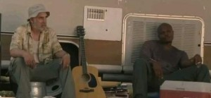Adam: You have a lot of scenes with Dale. Tell me about the relationship between Dale and T-Dog.
IronE: What you’ve seen on screen between Dale and T-Dog is an extension of our off screen relationship. In a perfect world, I would have had a father and he would have been like Mr. DeMunn (Dale). I love Jeffrey (Dale) He’s great! You’re not gonna make me cry. …yes you are.
***
Adam: Now T-Dog once brought up leaving the group with Dale, but later on blamed it on the infection (laughs). Are we going to see more of that play out?
IronE: Possibly… if T-Dog cuts himself, again and gets another infection, there’s no telling what might fly out of his mouth.
***
Adam: Ok, I have to ask about the ‘Walker down the Well’ scene. Tell me about shooting that scene.
IronE: The well walker was so hideous, we barely made it through that scene b/c I couldn’t stop gagging. I’m sure somebody has it on tape.
***
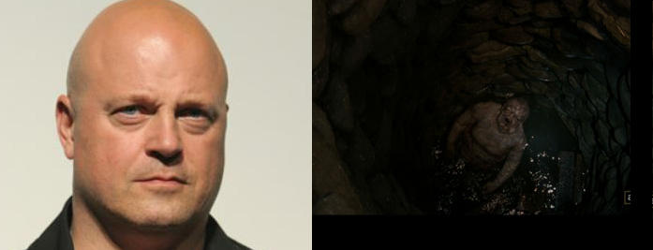Adam: I joked on Twitter that it was nice to see Michael Chiklis get a guest-spot on The Walking Dead as ‘The Walker Down the Well’ (laughs). Tell me you see the resemblance!
IronE: Be nice! hahaha
***
Adam: I think this might be a T-Dog highlight during that scene. After the Walker is out of the well (in 2 pieces) you walk up to it, smash his head in and say “Good thing we didn’t do something stupid like shooting it.”. (Laughs). That whole thing was just awesome. Tell me about THAT moment.
IronE: Thank you! I’m just glad the writers gave me one of the best lines of the episode.
***
Adam: During the last episode, we saw the Walkers in the Farm. What will be the fallout be of that discovery?
IronE: Total madness, chaos, disbelief, and insanity!!!!!!!!! hmph… that’s the entire season.
***
Adam: I always was suspecting that Herschel was hiding something. Seems like I was right. (Laughs)
IronE: YES YOU WERE!!! Bob, tell him what he’s won! hahaha
***
Adam: Speaking of hiding something, Lori is pregnant, Shane killed a guy, Glenn getting lucky. So many secrets! What’s T-Dog hiding? (Laughs)
IronE: If I tell you, it wouldn’t be a secret anymore. hahaha The only thing you’d do is go back and tell all your fans/listeners/readers.
***
Adam: Going forward, will any of these secrets come out? What can you tell us about that?
IronE: I can tell you that those secrets are NOTHING compared to the other secrets that will surface this season. WOW! You’re in for a treat.
***
Adam: You will eventually leave the farm, where do you go from there?
IronE: I think the survivors are going where ever they think the geeks are not.
***
Adam: Last episode we saw Merle return as a hallucination. But any chance we see the real thing by season’s end?
IronE: Merle is the mad, roving, racist redneck (like the alliteration?) who could pop up at any time.
***
Adam: If he does, will T-Dog thank him for getting The Clap? That should ease the tension (Laughs)
IronE: hahahaha! Whatever it takes to ease tension in real life, I’m all for it, but it wouldn’t be good tv. DRAMA! DRAMA! DRAMA! No thanking Merle for The Clap.
***
Adam: What can you tell us about the next few episodes? Any surprises in store?
IronE: Lori will kill a guy, Shane will get lucky and Glen will get pregnant. shhhh! Top secret.
(Very well played IronE)
***
Adam: The Walking Dead has been Renewed for Season 3. I will give you this time to confirm that T-Dog will still be there. We hope. Tell us. (Laughs)
IronE: T-Dog will still be there but IronE won’t. It’s just been confirmed that Michael Chiklis will replace me. He’s a good looking, bald guy with a nice tan. I should have seen it coming. hahahaha
***
Adam: You’ve been active on Twitter since the show premiered. Tell me about interacting with fans by Twitter?
IronE: I love my fans, dearly and am so thankful for them. Without fans, an actor has no career. I will NEVER take them for granted. I love my fans, dearly and am so thankful for them (deja-vu).
***
Adam: Season 2 has finished shooting. Preview the rest of the season by using up to 2 lines.
IronE: I did not think we could top season one but we have. TWD is the best show on planet Earth… and maybe Mars.
***
Adam: Finally, I ask this to all my interviewees. What have you been watching on TV lately?
IronE: TWD, TWD and ahh TWD (almost forgot)… and sports.
***
I thank IronE once again for having this chat. You can watch The Walking Dead on AMC every Sunday night.

